Blog 1

GitHub repository link: <https://github.com/YinLam-Chan/WEBAssessment3-BonAppetit-YinLamChan-Victoria>

The website that I am going to create is for a restaurant called Bon Appetit. This is a fancy restaurant, so the design of the website needs to deliver a luxury atmosphere.

The website needs to include the content that enough to show the general information of a restaurant, its products, and to differentiate itself from other restaurants. Before start designing the website, the wireframes of the website need to be done first. Wireframe is the initial basic design of the interface of the website, the designer draws the layout of the website with pan and paper, decide what content need to be included, what design elements like images or video will be used. The designer can improve the design based on the previous scratch and be specify on the detail of how the website will look like.

This is a four pages website, it includes the home page, the menu page, the staff page, and the contact page. A wireframe has been done for all pages, the basic design of all pages is to have a header for the restaurant name or logo, following by a navigation bar, then is the main content of that page, then is the footer of the page.

The following are the design wireframes:

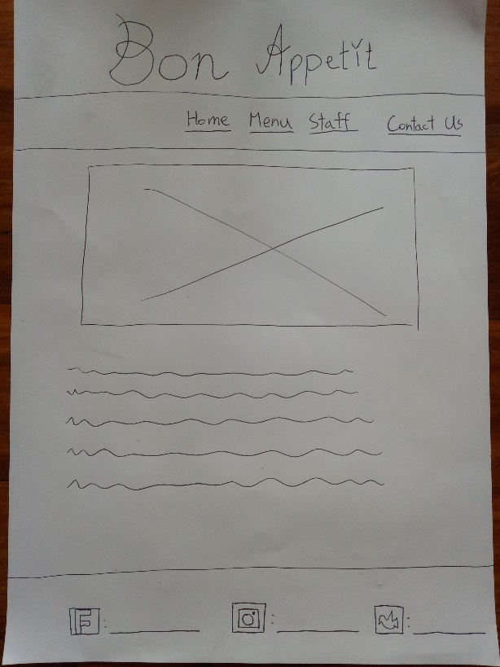 Home page

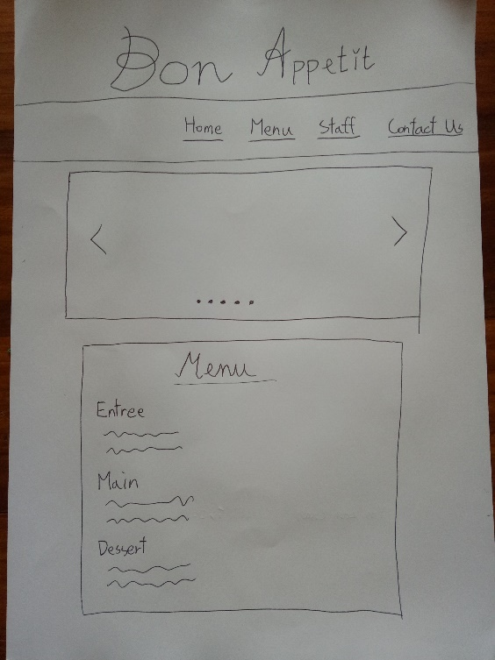

Menu page

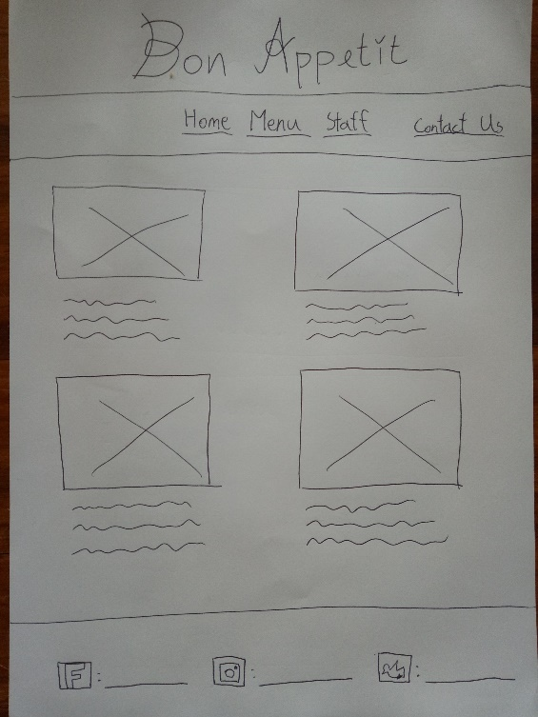

Staff page

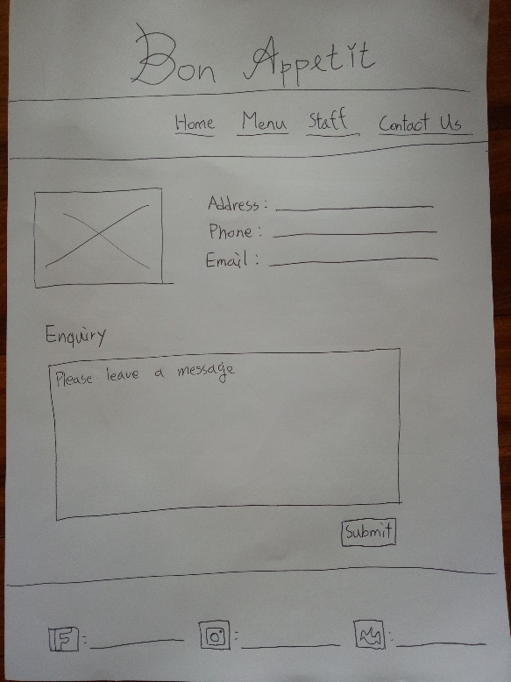

Contact page

All the work of the assessment 3 will be push to Github. Github is a platform where allows programmers to store their works. If a project is done by a team of programmers, they can put their works on Github and share with other colleagues, they can see the files and make changes of the project on Github.

Create a repository for a particular project, this is the location where the project is stored. Go to the code editor to point the work repository, type git clone and the URL of the repository from Github, type cd and the name of the repository, then type ls to see the list of files. If want to edit the file in the repository and push it to Github, type git status to see whether all files are up-to-date and on master, type git add . to add contributions that been made, type git commit -m to add a message mentioning what have been done. The git is committed, we can type git status to confirm if there is anything that need to commit otherwise it is ready to push the work to Github. Type git push origin master in order to push the work to the master branch, refresh Github to see the updated work repository.